**Advance EEIOA course 21/22**

**Week 11 Exercises: MRIO semantic works**

**Objectives**

* Understand and explain main results from EEIOA studies using the MRIO semantic
* Perform an MRIO analysis in Python
* Interpret the results using the MRIO semantic

**Part 1: Understanding and explaining MRIO results**

Wood et al. (2018) explore the way in which international trade contributes to 4 environmental pressures from the consumption of a population. Among their results, they show the growth in consumption-based footprints per capita between 1995 and 2011 for 11 world regions:



Figure 1. Growth in consumption-based footprints per capita between 1995 and 2011 for 11 world regions (1995 = 1) retrieved from Wood et al. (2018). GHG = greenhouse gas; OECD = Organization for Economic Cooperation and Development

1. Does figure 1 present any aspects related to MRIO semantic (e.g., logic, value visualization, language, etc.)? Provide two examples.
2. Which environmental footprints increase or decrease in Europe between 1995 and 2011?
3. Describe step-by-step how would you develop figure, bringing the possible equations required. Note: To facilitate the process, you can focus on one environmental pressure in one region, for one specific year (e.g., GHG emissions footprint in Europe for 2011).

**Part 2: Python exercises**

Hertwich and Peters (2009) developed an analysis of the carbon footprint of multiple countries in 2001. Their results show the carbon footprint of different final demand categories per product.

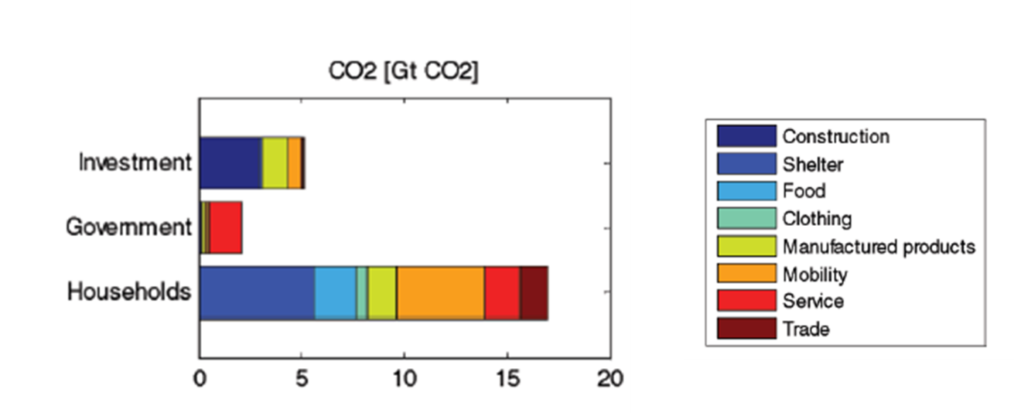

Figure 2. Global CO2 footprint for different consumption categories and users retrieved from Hertwich and Peters (2009)

Now, we want to reproduce these results by using EXIOBASE and compare any changes between 2001 and 2011

**Settings**

1. Import EXIOBASE in Python. You can use data import code from Week 10

**Final demand contribution per product category to CO2 footprint**

1. Calculate Leontief inverse matrix (L), and total output vector (x)
2. From satellite matrix (F), select row for CO2 (i.e., F_co2). This can be done using pd.loc, for example

|  |
| --- |
| co2_lab = 'CO2 - combustion - air'  F_co2 = F.loc[co2_lab, :] # select CO2 vector |

1. Calculate the co2 intensity vector (f_co2). Note: This vector might contain *nan*, and *inf* elements. Make sure to replace these elements for zeros, for example:

|  |
| --- |
| f_co2 = F_co2/x.transpose() # co2 intensity vector  f_co2 = f_co2.replace([np.inf, -np.inf], np.nan).replace(np.nan, 0) # replacing inf, -inf, and nan with zeros |

1. From the final demand matrix (Y), calculate the global final demand of households (y_hh), government expenditures (y_gov) and gross capital formation (y_cap). This can be done by using pd.xs, for example:

|  |
| --- |
| hh_lab = 'Final consumption expenditure by households'  y_hh = Y.xs(hh_lab, axis=1, level=1, drop_level=False) # selecting hh columns for all countries/regions  y_hh = y_hh.sum(1) # global final expenditure by household |

1. Calculate the CO2 footprint of each final demand category per product. For example:

|  |
| --- |
| co2_hh = f_co2 @ L @ np.diag(y_hh) # CO2 footprint by household expenditures |

At this point, it should be 3 vectors (for each final demand category from point 2) of 1 row with 9800 columns (i.e., 49 regions x 200 products)

1. Reshape each vector using *np.reshape*. For example:

|  |
| --- |
| co2_hh = np.array(co2_hh).reshape(49,200) # reshape to 49 countries/regions and 200 products |

Now, there should be 3 matrices with 49 rows (for each country/region) and 200 columns (for each product)

1. Sum up across rows. What is the resulted sum?
2. Combine the vectors and create a new matrix with 3 rows (for each final demand category) and 200 columns (for each product). Note: You can combine them in a new pandas dataframe

We will create 4 main product groups: Agriculture & Mining (ext), Manufacturing (man), Construction (con), and Services (ser). These are groups are different from those in Hertwich and Peters (2009), however, it can be used as proxy to compare the results between 2001 and 2011. Furthermore, we can use the following process to obtain more detailed product categories.

1. Copy and paste the following code lines that include the indices for the product groups

|  |
| --- |
| ### Index product categories  ext_ind = list(range(0,41)) # extraction categories (including agriculture, and mining)  man_ind = list(range(41,149)) # manufacturing (including food, clothing, other products)  con_ind = list(range(149,151)) # construction categories  ser_ind = list(range(151,200)) # services categories  ## Sum per product group  ext = df.iloc[:, ext_ind].sum(1)  man = df.iloc[:, man_ind].sum(1)  con = df.iloc[:, con_ind].sum(1)  ser = df.iloc[:, ser_ind].sum(1) |

1. Re-group the new dataframe and add labels. For example,

|  |
| --- |
| ## Re-group dataframe and add labels  df_new = pd.concat([ext, man, con, ser], axis=1)  df_new.index = ['Households', 'Goverment', 'Investment']  df_new.columns = ['Agriculture and Mining', 'Manufacturing', 'Construction', 'Services'] |

1. Create a bar graph showing the final contribution per product category to the CO2 footprint. Note: This can be done by using:

|  |
| --- |
| df_new.plot.barh(stacked=True) |

Note: Try to customize the graph by including title, labels and legend.

1. Which sector has a major contribution to the CO2 footprint of each final demand category?
2. What are the differences between the 2001 and 2011?

**References**

Hertwich, E. G., & Peters, G. P. (2009). Carbon footprint of nations: A global, trade-linked analysis. *Environmental Science and Technology*, *43*(16), 6414–6420. https://doi.org/10.1021/es803496a

Wood, R., Stadler, K., Simas, M., Bulavskaya, T., Giljum, S., Lutter, S., & Tukker, A. (2018). Growth in Environmental Footprints and Environmental Impacts Embodied in Trade: Resource Efficiency Indicators from EXIOBASE3. *Journal of Industrial Ecology*, *22*(3), 553–562. https://doi.org/10.1111/jiec.12735